**Supplementary material**

**Vortioxetine for depression in adults: a systematic review and dose-response meta-analysis of randomized controlled trials**

**Summary**

**Supplementary Table S1.** Search strategy

**Supplementary Figure S1.** Risk of bias assessment of the included studies.

**Supplementary Figure** **S2**. Meta-analysis of vortioxetine versus placebo: Response rate.

**Supplementary Figure** **S3**. Meta-analysis of vortioxetine versus SSRIs: Mean change in depression symptom scores.

**Supplementary Figure** **S4**. Meta-analysis of vortioxetine versus SNRIs: Mean change in depression symptom scores.

**Supplementary Figure** **S5**. Meta-analysis of vortioxetine versus placebo: Dropout rate for any reasons.

**Supplementary Figure** **S6**. Meta-analysis of vortioxetine versus placebo: Dropout rate for adverse events.

**Supplementary Figure** **S7**. Meta-analysis of vortioxetine versus placebo: Adverse events.

**Supplementary Figure** **S8**. Meta-analysis of vortioxetine versus placebo on mean change in depression symptom scores: Subgroup analysis based on dose.

**Supplementary Figure** **S9**. Meta-analysis of vortioxetine versus placebo on response rate: Subgroup analysis based on dose.

**Supplementary Figure** **S10**. Meta-analysis of vortioxetine versus placebo on dropout for any reasons: Subgroup analysis based on dose.

**Supplementary Figure** **S11**. Meta-analysis of vortioxetine versus placebo on dropout for adverse events: Subgroup analysis based on dose.

**Supplementary Figure** **S12**. Meta-analysis of vortioxetine versus placebo on adverse events: Subgroup analysis based on dose.

**Supplementary Figure** **S13.** Sensitivity analyses on the mean change in depression symptom scores.

**Supplementary Figure** **S14.** Spline curves with different knots and their goodness-of-fit.

**Supplementary Figure** **S15.** Dose-outcome curves for only fixed-dose studies.

**Supplementary Figure** **S16.** Dose-outcome curves estimated using a one-stage (blue line), a two-stage (red line) restricted cubic spline model and a two-stage linear (green line) model.

**Supplementary Figure** **S17.** Funnel plot for assessing the publication bias for mean change in depression symptom scores.

**Supplementary Figure** **S18.** Meta-analysis of vortioxetine versus SNRIs on mean change in depression symptom scores: Subgroup analysis based on different SNRIs.

**Supplementary Table S1.** Search strategy.

PubMed

| No. | Query | Results |
| --- | --- | --- |
| 1 | depressive disorder[MeSH Terms] OR depressive disorder, major[MeSH Terms] OR mood disorders[MeSH Terms] OR dysthymic disorder[MeSH Terms] OR depression[Text Word] OR depressive[Text Word] OR depressed[Text Word] OR dysthymia[Text Word] OR dysthymic[Text Word] OR affective symptoms[MeSH Terms] OR mdd[Title/Abstract] OR affective disorders[All Fields] | 704661 |
| 2 | "vortioxetine"[MeSH Terms] OR "vortioxetine"[Title/Abstract] OR "Lu AA21004"[All Fields] | 731 |
| 3 | (randomized controlled trial[Publication Type] OR controlled clinical trial[Publication Type] OR randomized[Title/Abstract] OR placebo[Title/Abstract] OR double-blind[Title/Abstract] OR controlled[Title/Abstract] OR randomly[Title/Abstract] OR trial[Title/Abstract] OR groups[Title/Abstract]) NOT ("animals"[MeSH Terms]) | 926749 |
| 4 | 1 AND 2 AND 3 | 66 |

Cochrane Library

| No. | Query | Results |
| --- | --- | --- |
| 1 | (depression):ti,ab,kw OR ('depressive disorder'):ti,ab,kw OR (depressed):ti,ab,kw OR ("mood disorders"):ti,ab,kw OR ("affective disorders") (Word variations have been searched) | 116423 |
| 2 | MeSH descriptor: [Depression] explode all trees | 17908 |
| 3 | MeSH descriptor: [Depressive Disorder, Major] explode all trees | 7079 |
| 4 | 2 OR 3 | 22861 |
| 5 | 1 OR 4 | 116423 |
| 6 | (Vortioxetine):ti,ab,kw OR (Lu AA21004) | 315 |
| 7 | MeSH descriptor: [Vortioxetine] explode all trees | 180 |
| 8 | 6 OR 7 | 315 |
| 10 | (randomized controlled trial):pt OR (controlled clinical trial):pt OR (randomized):ti,ab,kw OR (placebo):ti,ab,kw OR (randomly):ti,ab,kw OR (trial):ti,ab,kw OR (groups):ti,ab,kw | 1690820 |
| 11 | 5 AND 8 AND 10 | 244 |

Embase

| No. | Query | Results |
| --- | --- | --- |
| 1 | 'vortioxetine'/exp OR vortioxetine:ti,ab,kw OR 'lu aa21004' | 2110 |
| 2 | 'mood disorders':ti,ab,kw OR depressed:ti,ab,kw OR 'depressive disorder':ti,ab,kw OR depression:ti,ab,kw OR 'major depressive disorder':ti,ab,kw OR mdd:ti,ab,kw OR 'affective disorders' | 737337 |
| 3 | 'randomized controlled trial'/de OR 'controlled clinical trial'/de OR 'randomization'/de OR 'intermethod comparison'/de | 1332529 |
| 4 | random*:ti,ab,kw OR placebo:ti,ab,kw OR compare:ti,tt OR compared:ti,tt OR comparison:ti,tt OR ((evaluated:ab OR evaluate:ab OR evaluating:ab OR assessed:ab OR assess:ab) AND (compare:ab OR compared:ab OR comparing:ab OR comparison:ab)) OR (open NEXT/1 label):ti,ab,tt OR ((double OR single OR doubly OR singly) NEXT/1 (blind OR blinded OR blindly)):ti,ab,tt | 5019057 |
| 5 | 3 OR 4 | 5396643 |
| 6 | 1 AND 2 AND 5 | 551 |

Web of Science

| No. | Query | Results |
| --- | --- | --- |
| 1 | (TS=(vortioxetine)) OR TS=(Lu AA21004) | 1420 |
| 2 | (((((TS=(depression)) OR TS=(depressive disorder)) OR TS=("mood disorders")) OR TS=(depressive)) OR TS=("affective disorders")) OR TS=(MDD) | 1269453 |
| 3 | ((((((((TS=(randomized controlled trial)) OR TS=(controlled clinical trial)) OR TS=(randomized)) OR TS=(placebo)) OR TS=(random*)) OR TS=(trial)) OR TS=(groups)) OR TS=(blind* ) | 18572497 |
| 9 | 1 AND 2 AND 3 | 553 |

**Supplementary Figure S1.** Risk of bias assessment of the included studies.

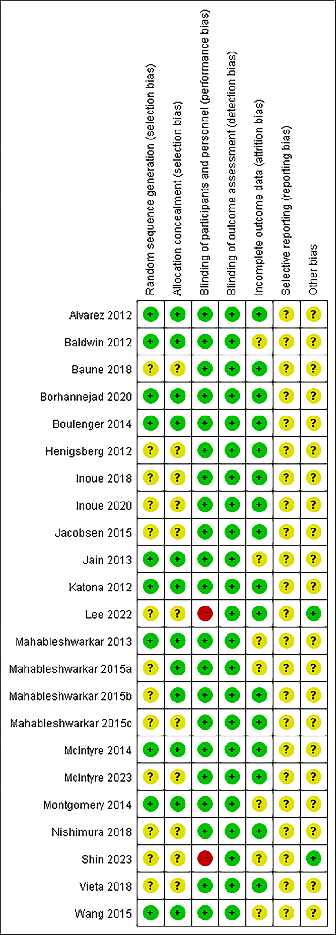

**Supplementary Figure** **S2**. Meta-analysis of vortioxetine versus placebo: Response rate.

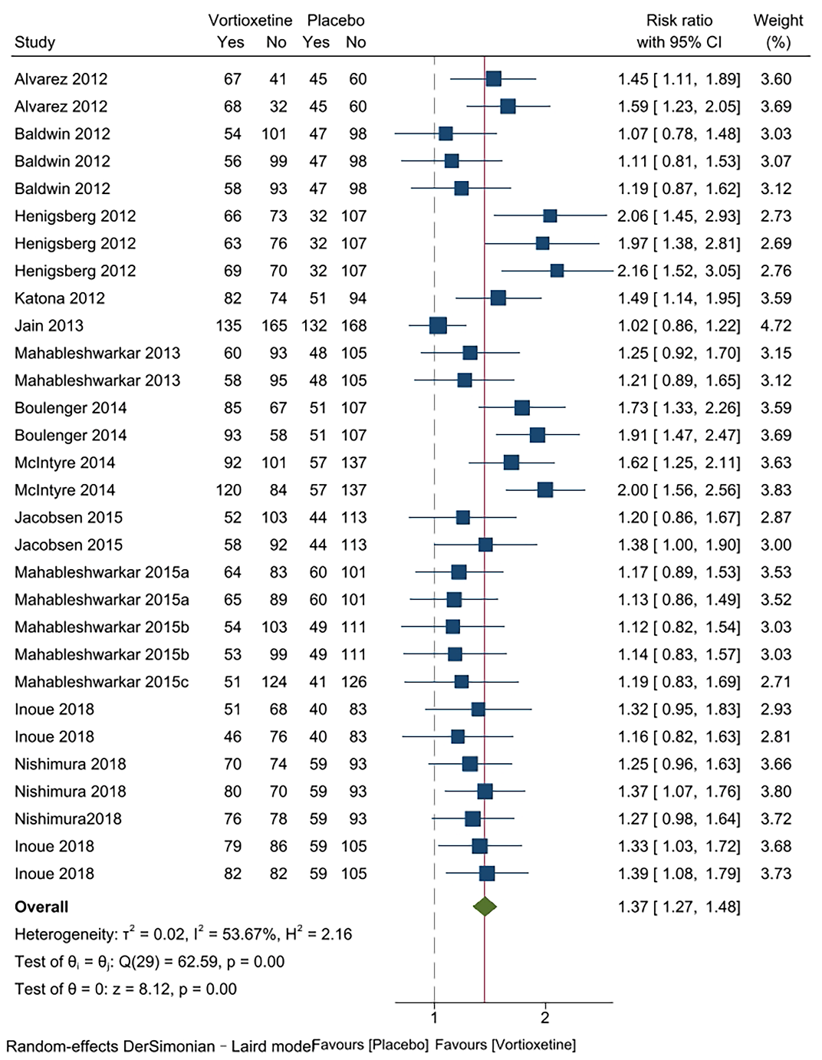

**Supplementary Figure** **S3**. Meta-analysis of vortioxetine versus SSRIs: Mean change in depression symptom scores.

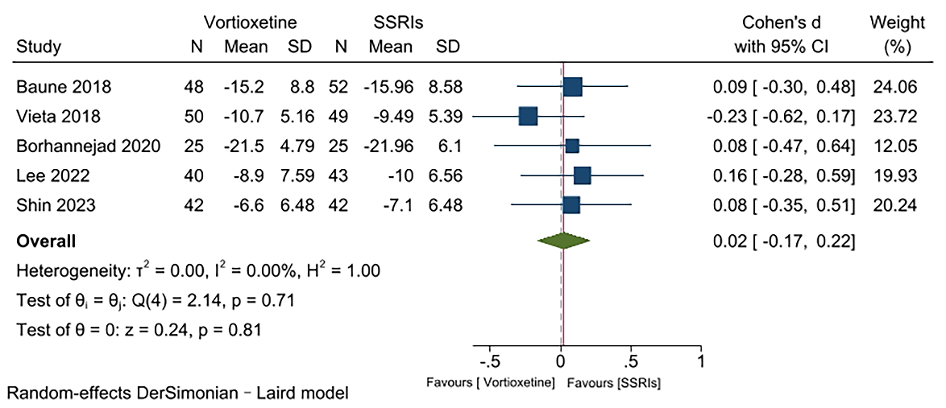

**Supplementary Figure** **S4**. Meta-analysis of vortioxetine versus SNRIs: Mean change in depression symptom scores.

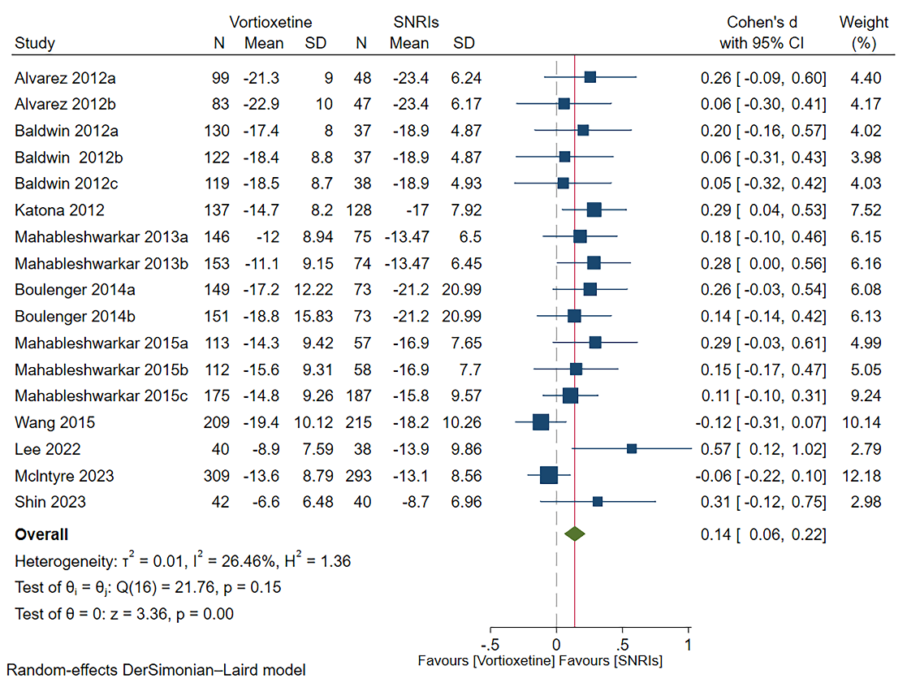

**Supplementary Figure** **S5**. Meta-analysis of vortioxetine versus placebo: Dropout rate for any reasons.

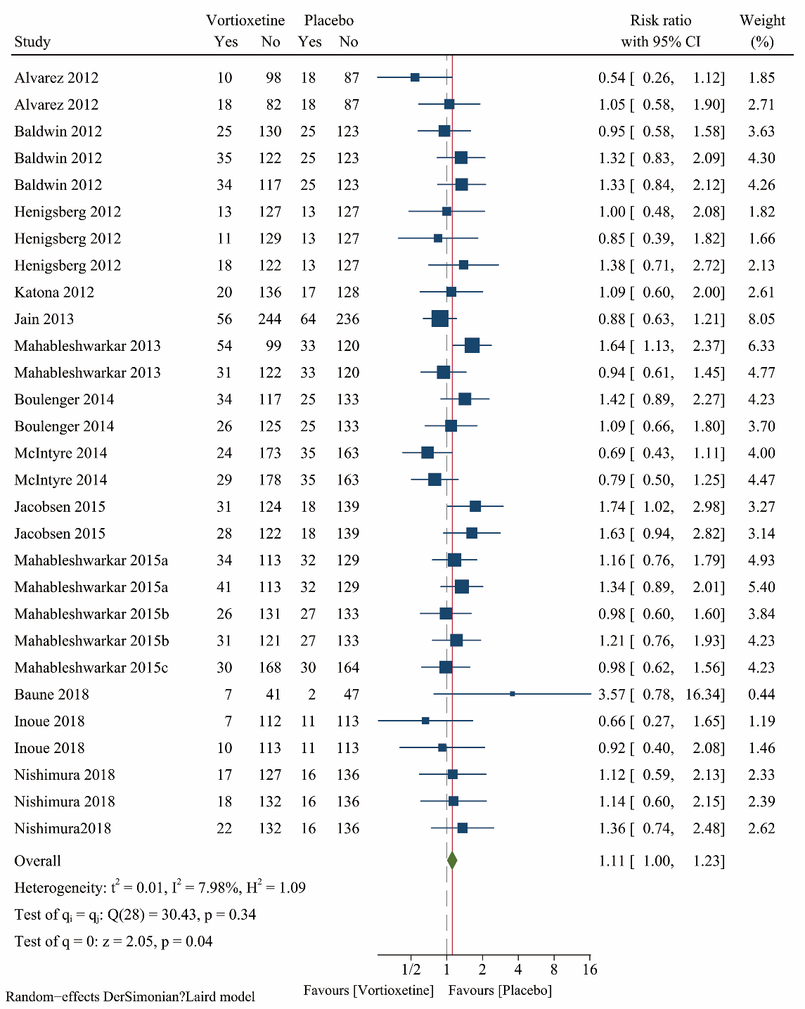

**Supplementary Figure** **S6**. Meta-analysis of vortioxetine versus placebo: Dropout rate for adverse events.

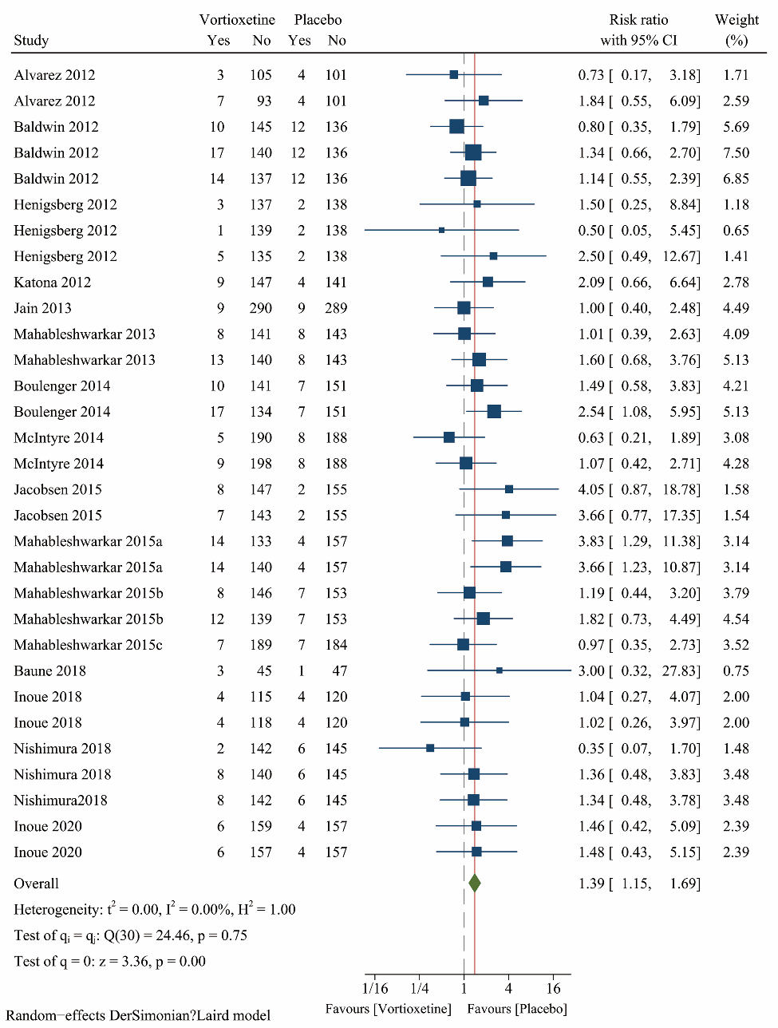

**Supplementary Figure** **S7**. Meta-analysis of vortioxetine versus placebo: Adverse events.

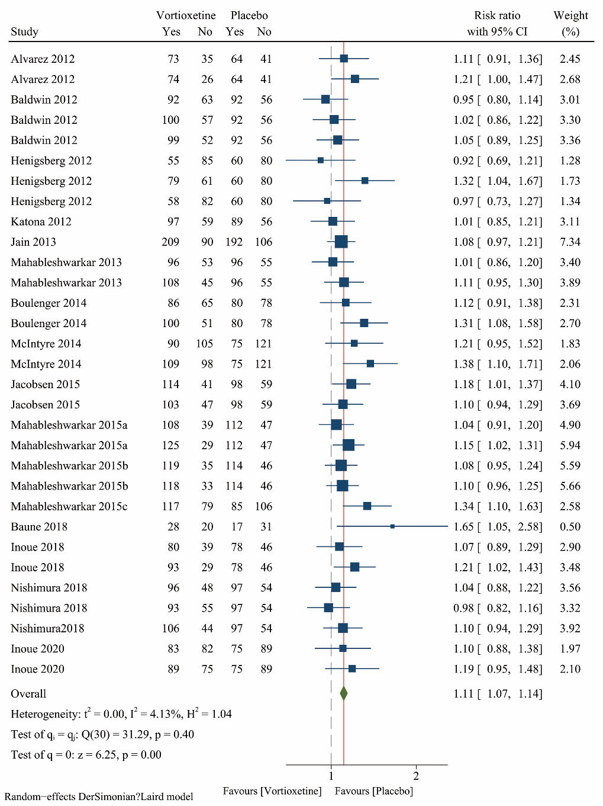

**Supplementary Figure** **S8**. Meta-analysis of vortioxetine versus placebo on mean change in depression symptom scores: Subgroup analysis based on dose.

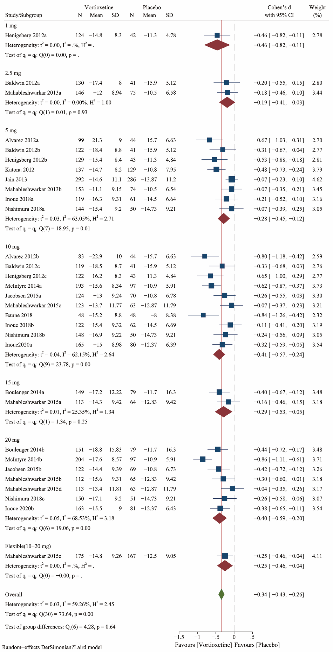

**Supplementary Figure** **S9**. Meta-analysis of vortioxetine versus placebo on response rate: Subgroup analysis based on dose.

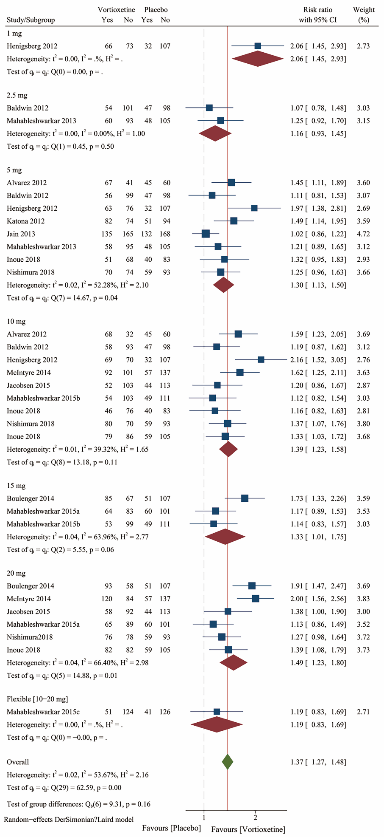

**Supplementary Figure** **S10**. Meta-analysis of vortioxetine versus placebo on dropout for any reasons: Subgroup analysis based on dose.

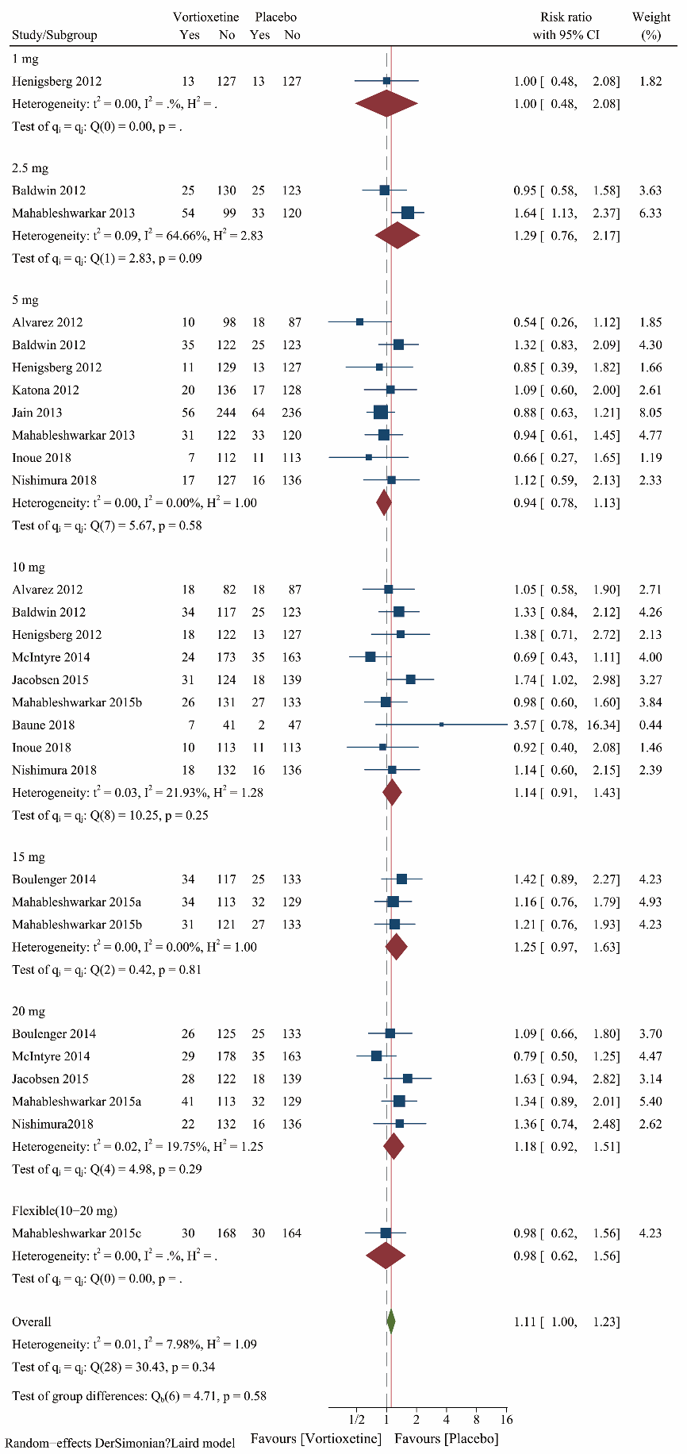

**Supplementary Figure** **S11**. Meta-analysis of vortioxetine versus placebo on dropout for adverse events: Subgroup analysis based on dose.

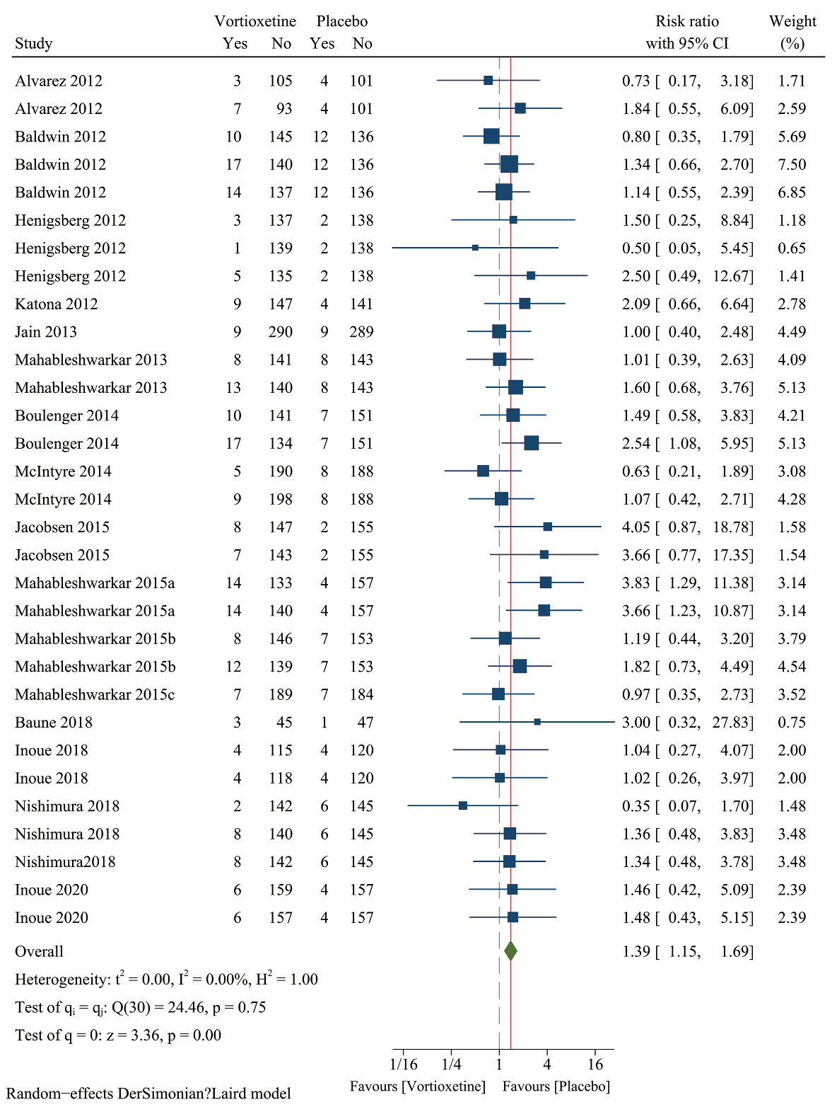

**Supplementary Figure** **S12**. Meta-analysis of vortioxetine versus placebo on adverse events: Subgroup analysis based on dose.

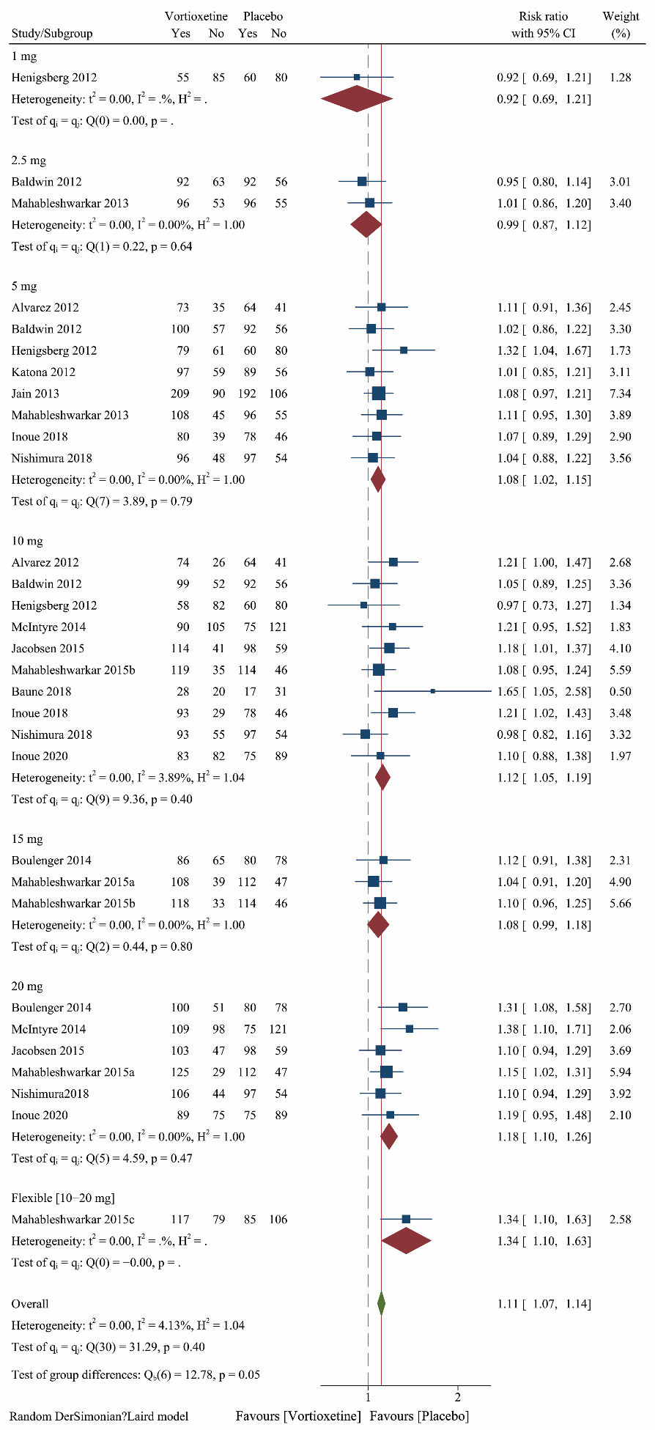

**Supplementary Figure** **S13.** Sensitivity analyses on the mean change in depression symptom scores.

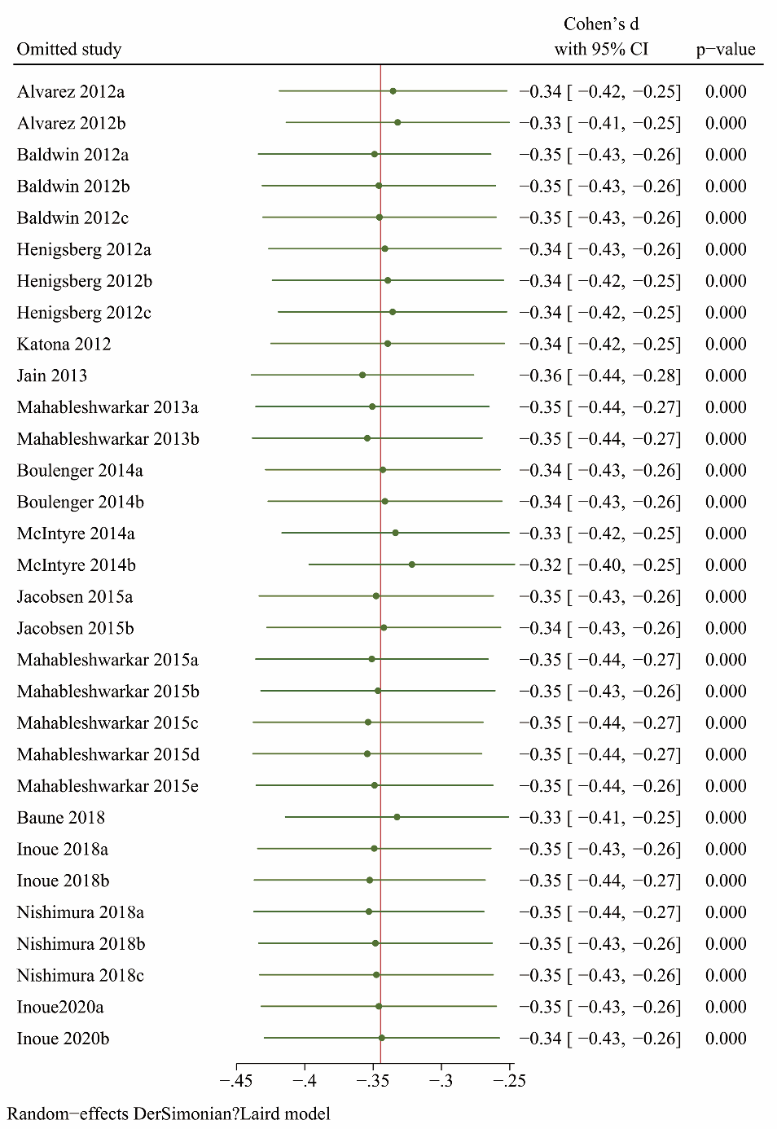

**Supplementary Figure** **S14.** Spline curves with different knots and their goodness-of-fit.

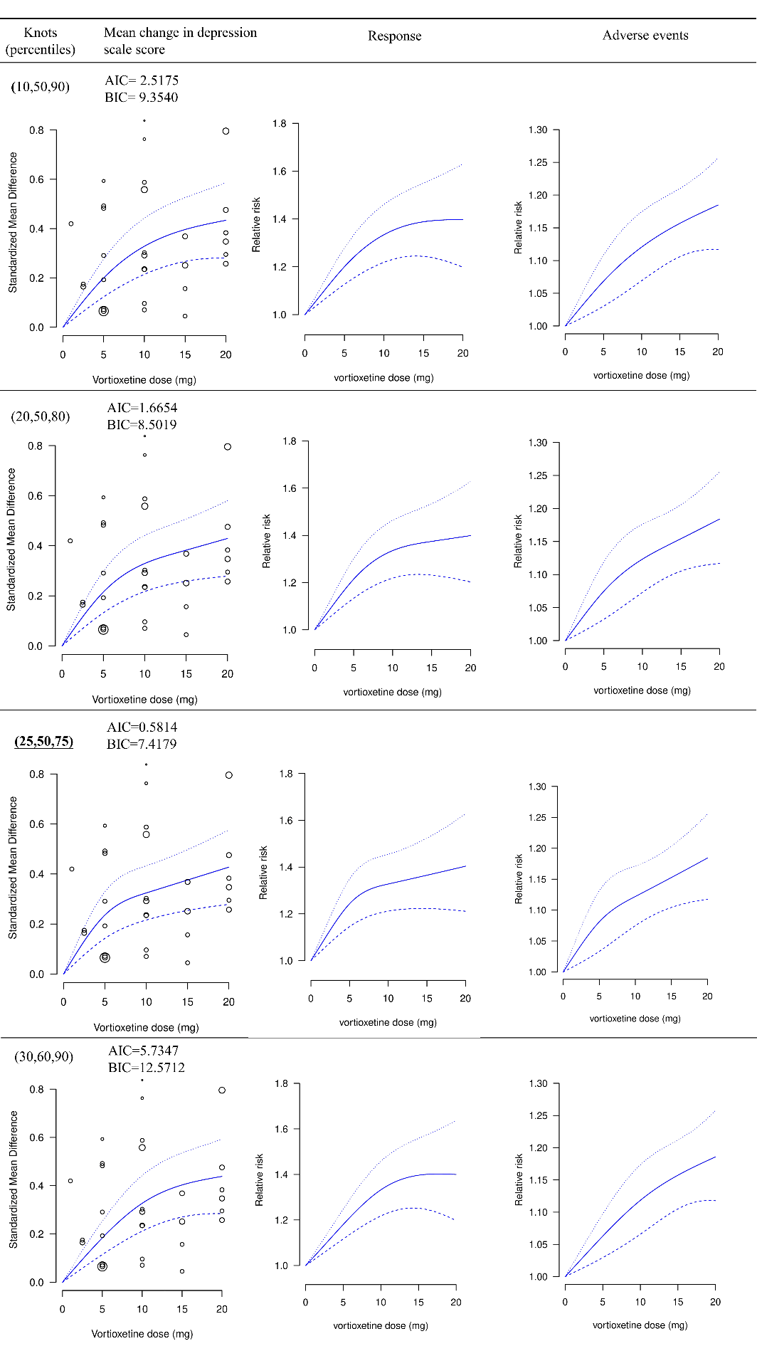

Abbreviations: AIC=Akaike Information Criterion; BIC=Baeysian Information Criterion. Bold and underlined shows the model with the best fit. The dash lines represent 95% confidence intervals.

**Supplementary Figure** **S15.** Dose-outcome curves for only fixed-dose studies. The dash lines represent 95% confidence intervals.

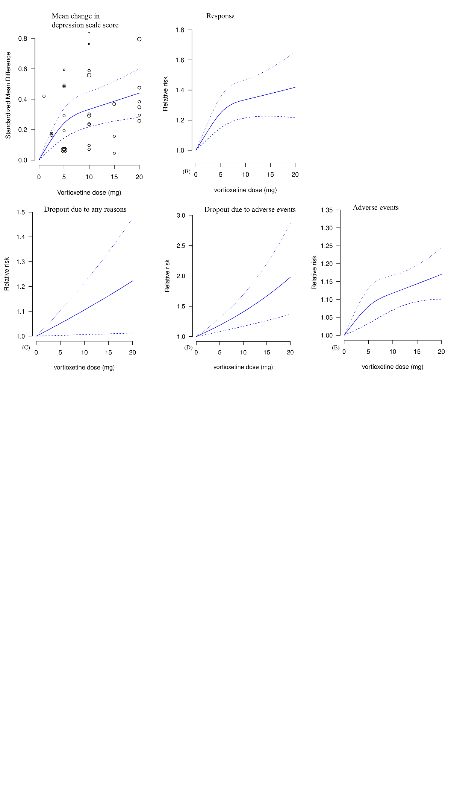

**Supplementary Figure** **S16.** Dose-outcome curves estimated using a one-stage (blue line), a two-stage (red line) restricted cubic spline model and a two-stage linear (green line) model.

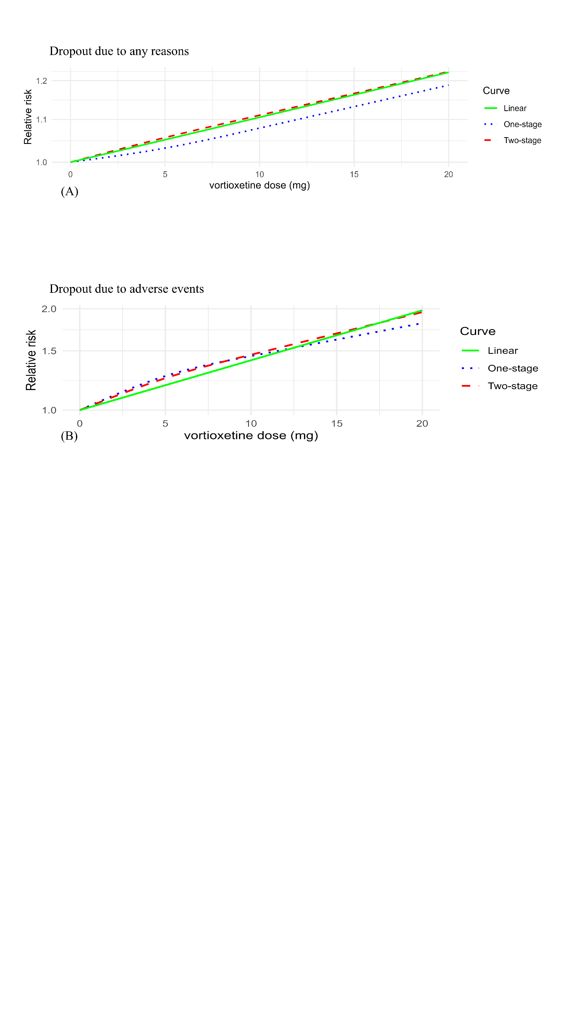

**Supplementary Figure** **S17.** Funnel plot for assessing the publication bias for mean change in depression symptom scores.

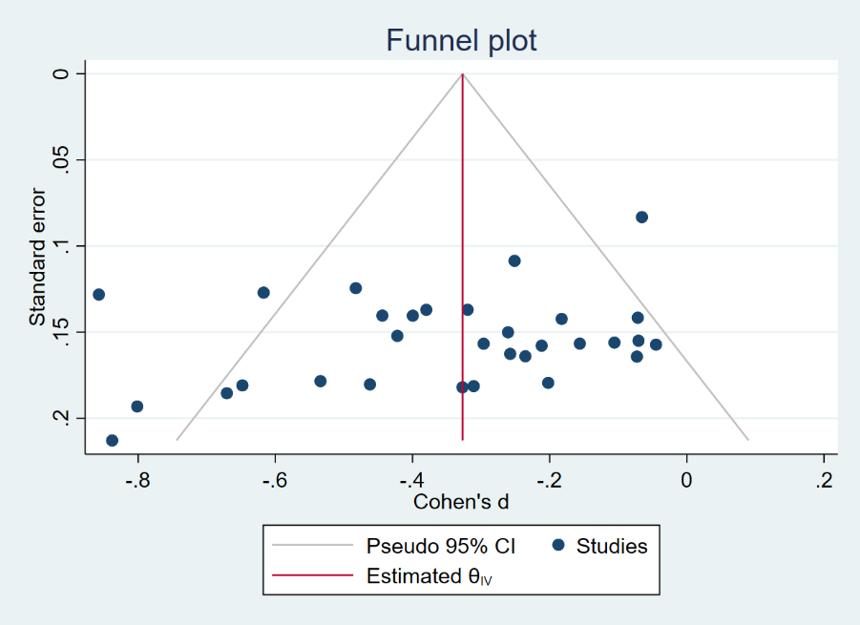

**Supplementary Figure** **S18.** Meta-analysis of vortioxetine versus SNRIs o mean change in depression symptom scores: Subgroup analysis based on different SNRIs.

